Click. Cook. Connect. Young Slovak launches slovakcooking.com to celebrate the diverse tastes of home
For one reason or another, the one dish that vast majority of second or third generation Slovak Americans associate with Slovakia are stuffed cabbage leaves called holubky. As a young person from Slovakia, I found this quite strange. After all, the first time I tried this concoction was not in Slovakia, but in the United States, at a Christmas party highlighting traditional Slovak dishes.
Is this some mistake? Turns out, not quite. Stuffed cabbage was actually very popular at the turn of the 19th and 20th century and can still be readily found in eastern Slovakia, the region which many immigrants called their home. But these days, you won’t find it in many Slovak restaurants. Instead, the national dish of Slovakia is small potato dumplings mixed with special Feta-like cheese called bryndza. Other popular dishes include sauerkraut soup, baked chicken, breaded and fried pork schnitzels and many types of stews and goulashes. And then there are the many kinds of sweets, ranging from home baked buchty to elaborate cakes found in the many pastry shops dotting the country.
After several years of living in the United States, I began to miss these delicacies. There is only so much pizza and sandwiches one can handle! I figured I could learn how to cook Slovak food and share my culinary adventures with others. That’s how slovakcooking.com got started. The year-old site now features over 70 illustrated step-by-step recipes and receives over 10,000 monthly visitors. The best thing, there is nothing hard about cooking Slovak food. Slovak cuisine evolved to easily satisfy the hunger of shepherds and peasants working Slovak fields while relying on ingredients grown locally. And as far as holubky go? Although I may never become a fan, I have realized this dish is part of the Slovak-American identity. If you have a great recipe for this or any other Slovak food, please share it at slovakcooking.com. Dobrú chut!
###
Lubos Brieda has been living in the United States since 1994. He is currently pursuing his doctorate in Aerospace Engineering at the George Washington University in Washington D.C. Besides maintaining slovakcooking.com, he is also active in the local Slovak community by assisting with organizing events through Washington D.C. Slovak Meetup.
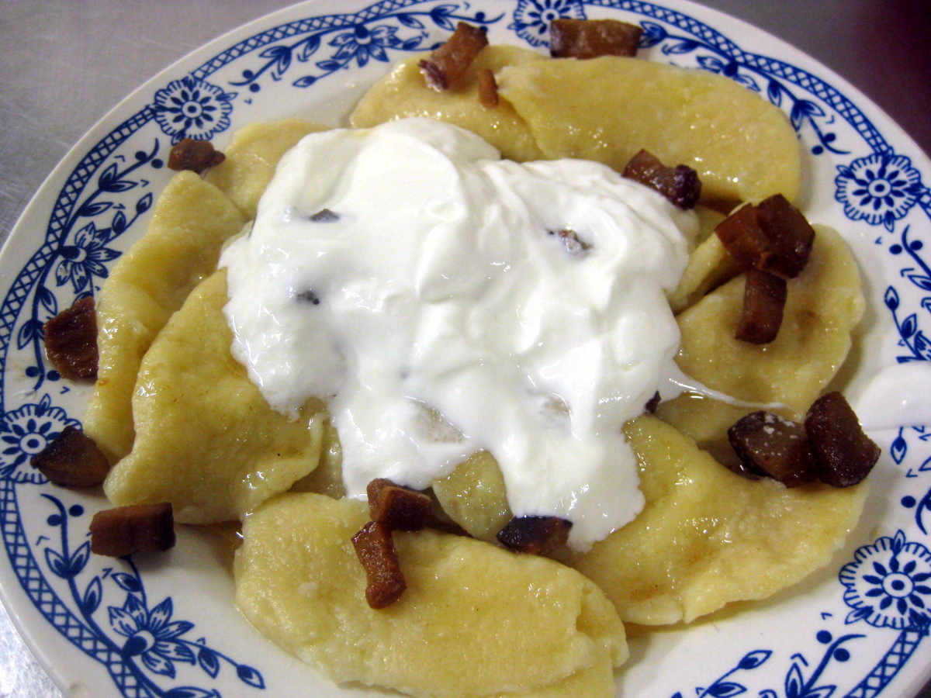
Slovak bryndza pierogi topped with fried bacon bits and sour cream

